**Coding Assignment**

Name: Jeevan Sai Badana

Mail: [jeevansai100@gmail.com](mailto:jeevansai100@gmail.com)

Date: 02-02-2024

1.Explain Pandas for Data Processing & execute Reading CSV Data using Pandas &Read Data from CSV Files to Pandas Dataframes &Filter Data in Pandas Dataframe using query.

**Solution:-**

**Pandas for Data Processing:**

Pandas is a powerful open-source data manipulation and analysis library for Python. It provides data structures like Series and DataFrame that are efficient for working with structured data.

* **DataFrame:** A two-dimensional table with rows and columns, similar to a spreadsheet or SQL table.
* **Series:** A one-dimensional labeled array capable of holding any data type.
* **Data Cleaning:** Pandas provides tools for handling missing data, converting data types, and other data cleaning tasks.
* **Data Aggregation:** Perform grouping and aggregation operations on data.

**Reading CSV Data using Pandas:**

I have one csv file named as file1.csv so now I read that file using pandas. By using pandas reading file is much simple and code as follows:

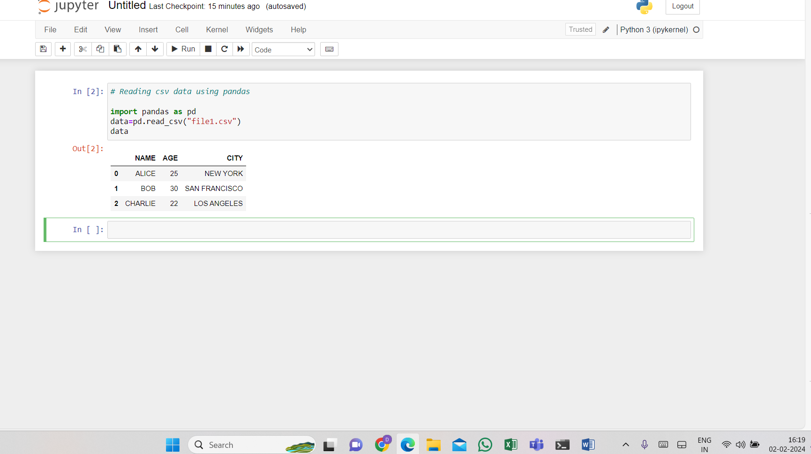

**Read Data from CSV Files to Pandas DataFrames:**

Now we read the same csv file using Dataframes

For this we create data frame and pass the file into it.Here is the below code

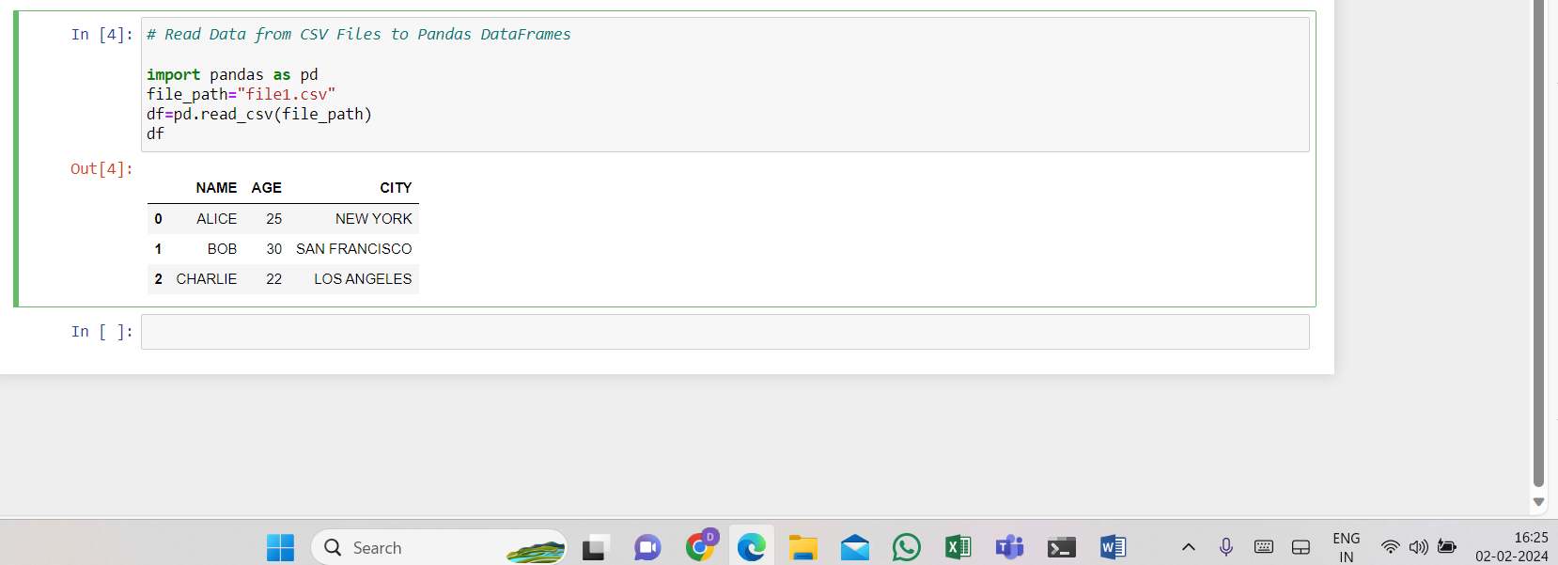

**Filter Data in Pandas DataFrame using query:**

Now we can filter data that the AGE>22

